21BDS0340

Abhinav Dinesh Srivatsa

Exploratory Data Analysis Lab

Experiment – VIII

**Code:**

library(dplyr)

library(ggplot2)

library(corrplot)

# performing exploratory data analysis with mtcars

data = mtcars

**Output:**

> library(dplyr)

> library(ggplot2)

> library(corrplot)

>

> # performing exploratory data analysis with mtcars

> data = mtcars

**Code:**

# viewing data structure and dimensions

str(data)

dim(data)

**Output:**

> # viewing data structure and dimensions

> str(data)

'data.frame': 32 obs. of 11 variables:

$ mpg : num 21 21 22.8 21.4 18.7 18.1 14.3 24.4 22.8 19.2 ...

$ cyl : num 6 6 4 6 8 6 8 4 4 6 ...

$ disp: num 160 160 108 258 360 ...

$ hp : num 110 110 93 110 175 105 245 62 95 123 ...

$ drat: num 3.9 3.9 3.85 3.08 3.15 2.76 3.21 3.69 3.92 3.92 ...

$ wt : num 2.62 2.88 2.32 3.21 3.44 ...

$ qsec: num 16.5 17 18.6 19.4 17 ...

$ vs : num 0 0 1 1 0 1 0 1 1 1 ...

$ am : num 1 1 1 0 0 0 0 0 0 0 ...

$ gear: num 4 4 4 3 3 3 3 4 4 4 ...

$ carb: num 4 4 1 1 2 1 4 2 2 4 ...

> dim(data)

[1] 32 11

**Code:**

# summarising the data

summary(data)

**Output:**

> # summarising the data

> summary(data)

mpg cyl disp hp drat

Min. :10.40 Min. :4.000 Min. : 71.1 Min. : 52.0 Min. :2.760

1st Qu.:15.43 1st Qu.:4.000 1st Qu.:120.8 1st Qu.: 96.5 1st Qu.:3.080

Median :19.20 Median :6.000 Median :196.3 Median :123.0 Median :3.695

Mean :20.09 Mean :6.188 Mean :230.7 Mean :146.7 Mean :3.597

3rd Qu.:22.80 3rd Qu.:8.000 3rd Qu.:326.0 3rd Qu.:180.0 3rd Qu.:3.920

Max. :33.90 Max. :8.000 Max. :472.0 Max. :335.0 Max. :4.930

wt qsec vs am gear

Min. :1.513 Min. :14.50 Min. :0.0000 Min. :0.0000 Min. :3.000

1st Qu.:2.581 1st Qu.:16.89 1st Qu.:0.0000 1st Qu.:0.0000 1st Qu.:3.000

Median :3.325 Median :17.71 Median :0.0000 Median :0.0000 Median :4.000

Mean :3.217 Mean :17.85 Mean :0.4375 Mean :0.4062 Mean :3.688

3rd Qu.:3.610 3rd Qu.:18.90 3rd Qu.:1.0000 3rd Qu.:1.0000 3rd Qu.:4.000

Max. :5.424 Max. :22.90 Max. :1.0000 Max. :1.0000 Max. :5.000

carb

Min. :1.000

1st Qu.:2.000

Median :2.000

Mean :2.812

3rd Qu.:4.000

Max. :8.000

**Code:**

# missing data checking

sum(is.na(data))

**Output:**

> # missing data checking

> sum(is.na(data))

[1] 0

**Code:**

# outlier detection

ggplot(data, aes(y=mpg)) +

geom_boxplot(fill="#cebae6") +

theme_minimal()

**Output:**

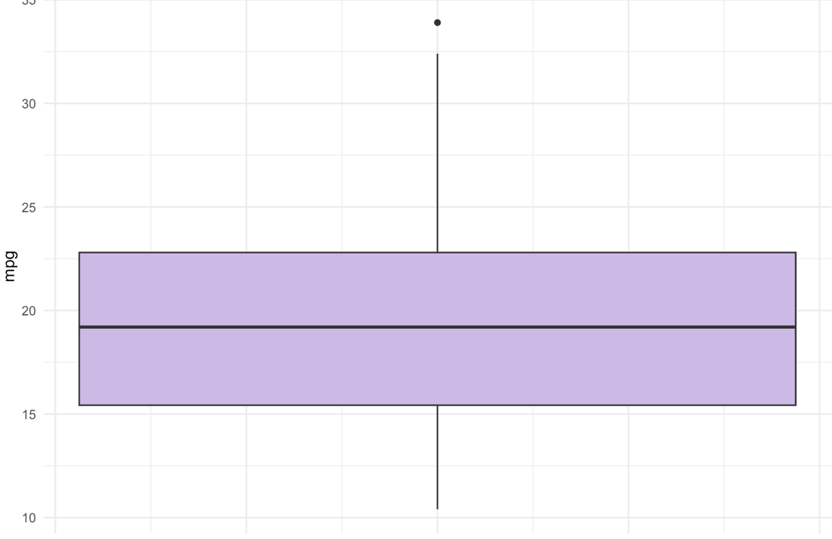

**Code:**

# univariate analysis

ggplot(data, aes(x=hp)) +

geom_histogram(binwidth=20, fill="#cebae6", color="black")

**Output:**

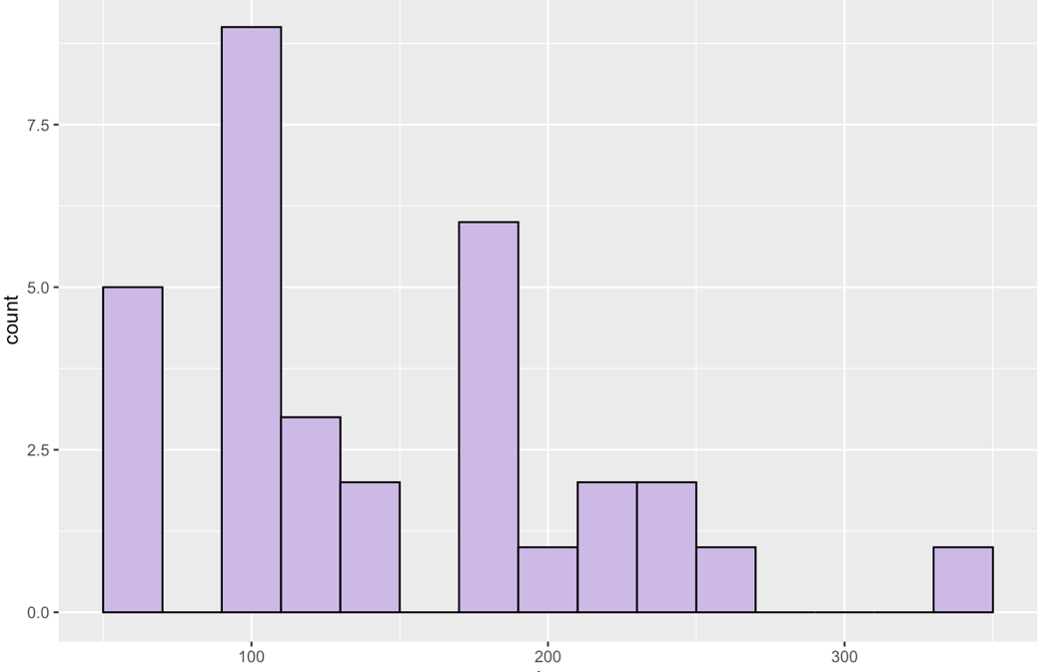

**Code:**

# univariate analysis

cyl_counts <- as.data.frame(table(data$cyl))

colnames(cyl_counts) <- c("Cylinders", "Count")

ggplot(cyl_counts, aes(x="", y=Count, fill=Cylinders)) +

geom_bar(stat="identity", width=1) +

coord_polar(theta = "y") +

theme_void()

**Output:**

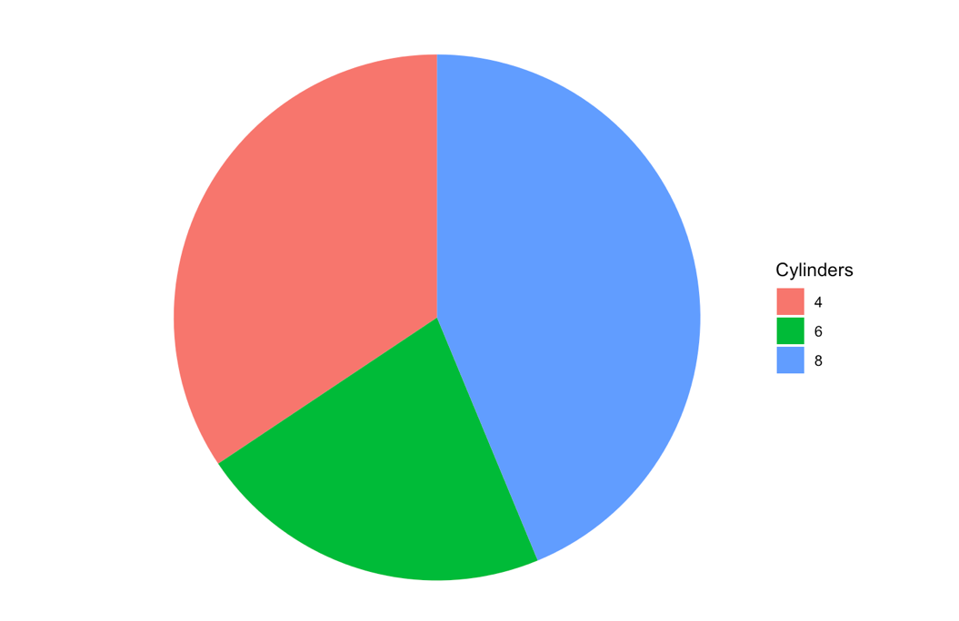

**Code:**

data$gear = as.factor(data$gear)

ggplot(data, aes(x=gear)) +

geom_bar(fill="#cebae6", color="black")

**Output:**

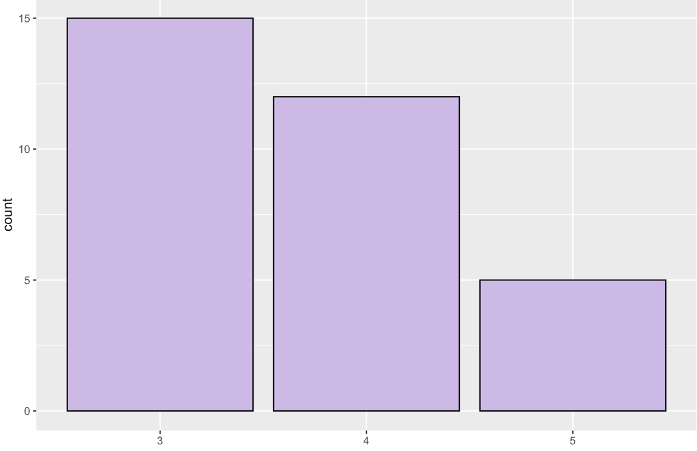

**Code:**

# bivariate analysis

ggplot(data, aes(x=hp, y=mpg)) +

geom_point(color="purple") +

theme_minimal()

**Output:**

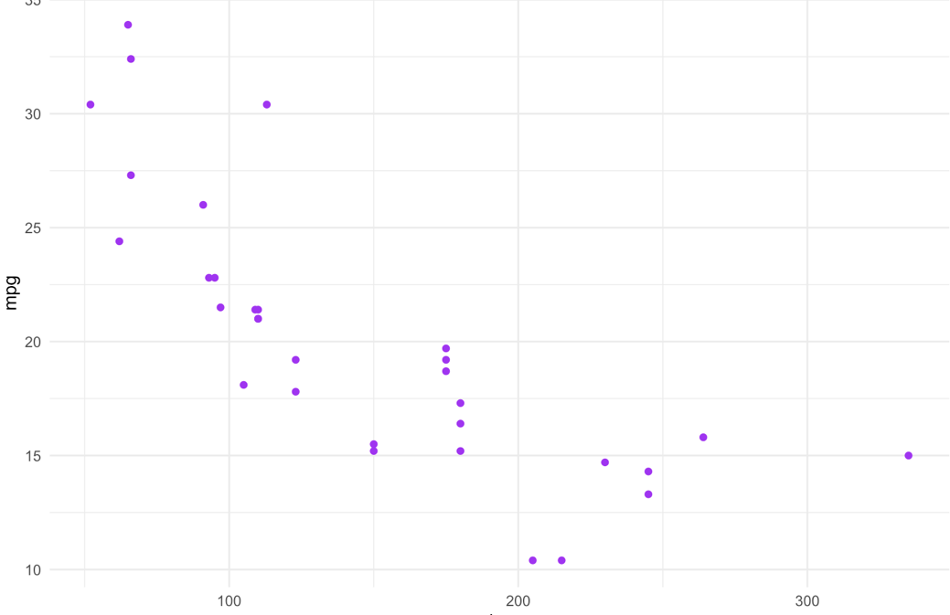

**Code:**

ggplot(data, aes(x=cyl, y=mpg, fill=cyl)) +

geom_point()

**Output:**

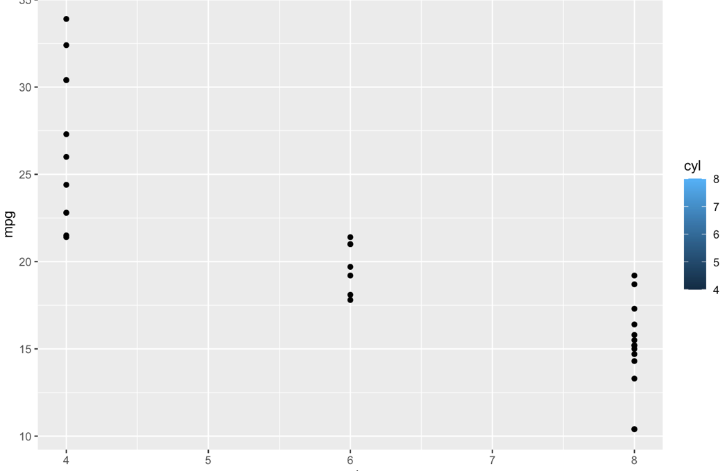

**Code:**

# multivariate analysis

data$cyl = as.factor(data$cyl)

data$gear = as.factor(data$gear)

**Output:**

> # multivariate analysis

> data$cyl = as.factor(data$cyl)

> data$gear = as.factor(data$gear)

**Code:**

ggplot(data, aes(x=wt, y=mpg, color=hp)) +

geom_point() +

scale_color_gradient(low="blue", high="red") +

facet_grid(cyl~gear) +

theme_minimal()

**Output:**

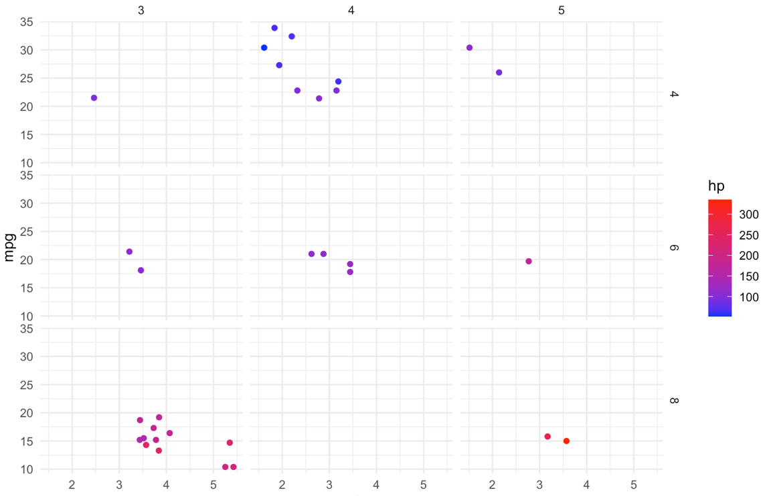

**Code:**

# correlation analysis

cor_matrix = cor(data %>% select_if(is.numeric))

corrplot(cor_matrix)

**Output:**

